EPS PTA is proud to present the newest East Prairie spirit accessory!
SHOW YOUR SCHOOL PRIDE
WITH AN EAST PRAIRIE SCHOOL
CAR MAGNET
* Order yours today for only $3 each *

    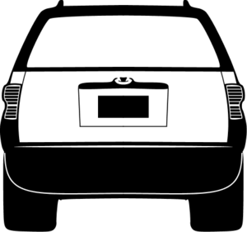
Magnets are 5 ½” wide

Car magnets will be available for purchase on Registration day,
May 2nd at the PTA table or submit an order form. Buy one today!

To order, submit the form below along with your payment in an envelope marked “PTA Magnet Order.” Cash and checks (made out to East Prairie PTA) are accepted. Orders will be delivered through your child approximately 2-3 days after submitting your order. Contact Claudia Lopez (clopezeps.pta@gmail.com) with any questions.

EAST PRAIRIE PTA CAR MAGNET ORDER FORM

YOUR NAME _______________________________________________ PHONE # ___________________________

CHILD’S NAME _____________________________________________

TEACHER’S NAME __________________________________________

TOTAL # of MAGNETS _______________ AMOUNT ENCLOSED $ _______________

